It's not digested or absorbed in the stomach. It stays in the bowel and helps certain beneficial bacteria to grow. Inulin is a starchy substance found in a wide variety of fruits, vegetables, and herbs, including wheat, onions, bananas, leeks, artichokes, and asparagus.

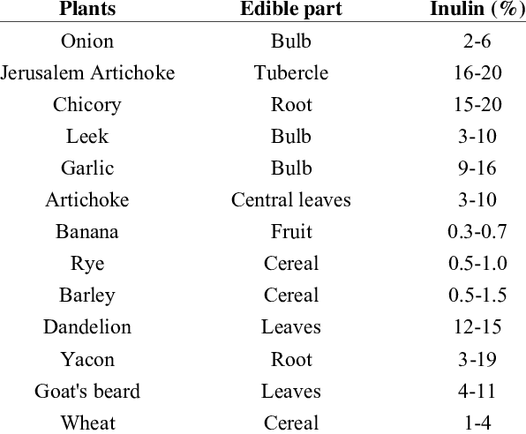

Sources:

* <https://www.researchgate.net/figure/Quantity-of-inulin-present-in-some-foods_tbl2_260404230>
* <https://www.livestrong.com/article/364660-foods-that-contain-inulin/>